Global Assembly for Knowledge Democracy
Pre-Conference Regional Workshop
Teacher Action Researchers on Youth Participatory Action Research (YPAR) and Leadership
Moravian College
Bethlehem, Pennsylvania, USA
April 18, 2017

Summary: Through a unique community, public school, and local business partnership, public schools throughout the Lehigh Valley region of eastern Pennsylvania, USA, with a population of nearly one million residents, joined together to provide opportunities for public school student leadership through student exploration of Stephen Covey’s 7 Habits of Highly Effective people as presented in The Leader in Me (Covey, 2014). Moravian College’s action research-based graduate education program awarded 14 teacher action research fellowships to support local K-8 teachers and staff developers to utilize a participatory action research approach in a year-long study of student leadership in local public schools (Duncan-Andrade & Morrell, 2008; Ozer & Wright, 2012; McNiff, 2017). The teacher action researchers’ approach to inquiry was influenced by Fals Borda, Kemmis, Ledwith and others through readings from the Palgrave International Handbook of Action Research (Rowell, Bruce, Shosh, & Riel, 2017) prior to data collection. Teacher action researchers met in breakout sessions on 18 April 2017 to begin to respond to the question: To what extent can epistemological, ideological and political differences be reconciled in the interest of a sustainable and socially just world?

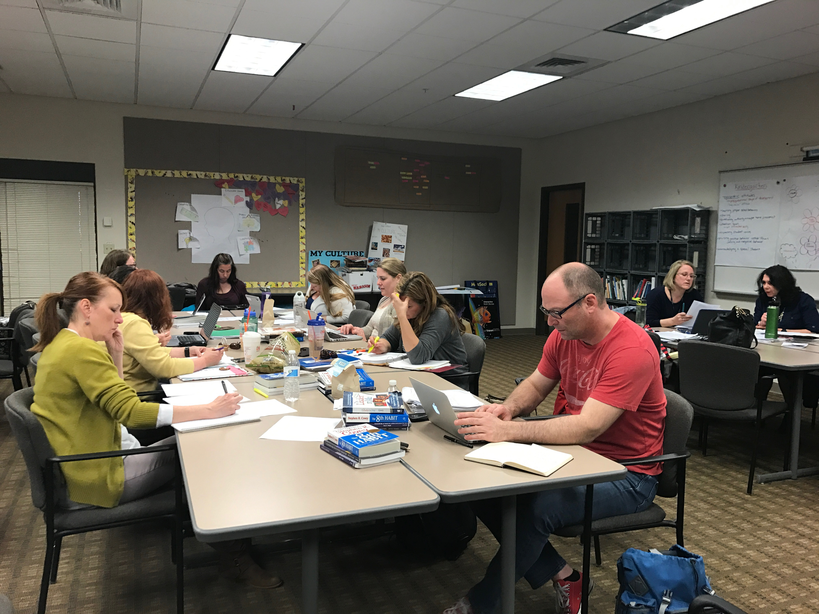
Leader Lehigh Valley Teacher Research Fellows meet as part of a Global Assembly
for Knowledge Democracy Pre-Conference Regional Workshop at Moravian College
in Bethlehem, Pennsylvania on 18 April 2017.

Focus Group Summary Responses

What knowledge ecologies are appropriate/recognized for our context? And why?

- Shift responsibility to students—opportunities to step into leadership role
  - Try on leadership roles—builds confidence in supportive environments
- Create systems of shared leadership for all staff (support and professional staff)
  - Intrinsic motivation; staff buy-in
  - Role of instructional leader (principal) empowering staff to be equal partners; honoring voices; modeling
- Paradigm shifts (leadership, motivation, change, education, potential)
  - Looking at things differently; seeking to understand before action
- Empower student voice to lead, create, inspire change
  - Equal stakeholders and partners in the educational process
- Create community partnerships
  - Increases resource and support

How can we (do we) address the democratization of knowledge within our teaching and research?

- The process of using youth participatory research allows the average teacher to have a voice in how the school is run. By it being participatory we are extending that voice to include the youngest and neediest within our schools.

- Participatory action research and the culture laid by the paradigm shift of the Leader in Me, allows for more active learning as opposed to the traditional transmission model. As Wright (2015) explains, “Active learning empowers students to analyze information, explain their analyses and create knowledge” (p. 15).

- The Leader in Me helps children take ownership of their own learning. It transfers the power of learning to them.

- The Leader in Me causes a system of checks and balances with both teachers and students having a voice in decisions.

- We want to look at curricular models are project-based, “hybrid learning,” personalized learning, and more experiential. Moving away from workbook, pencil- paper based.

- There needs to be meaningful, authentic data collection. It doesn’t necessarily have to be paper/pencil assessment.

What are the political and pragmatic implications of knowledge democratization? What principles/philosophies might inform them?
  - Movement from top-down management to bottom-up and, more grassroots movements in politics and societies.
    - Instead of ideas and change moving from superintendent to principal to teacher to students, going the other way around.
      - Student/parent polls and advice on curriculum
  - Power struggle
    - Union/group strength or strength in numbers
    - Administrative “bullying”
  - Principles of fairness - right to know
  - Principle of control/voice finding - leading their own journey to know what they want to know

What research methodologies might advance such knowledge?
  - Student feedback, input, etc.
  - Diversity of narrative forms
  - Discourse analysis
  - Dana Wright in Active Learning: “Jocelyn’s vision focuses on building skills and leadership development…. ‘My vision is that they learn all these different skills and I hope that whatever they learn that they take it on and remember and use it later in their life’” (p. 50).
    - Focus Group Facilitation Exercise
    - Food Matrix data analysis activity (p. 60)
  - Chris Buttimer:
    - “Adult collaborators who abide by the guiding principles of YPAR believe strongly that young people can conduct high-quality research and effect real change. As such, they engage youth in the same rigorous inquiry process as professional action researchers: choose a research question and generate a hypothesis, read relevant literature, develop research tools, gather and analyze data, create an action plan based on the findings, and take action” (Akom, 2009; Freire, 1970/2000; Sabo Flores, 2008).
    - “The youth researchers read relevant literature from fields such as sociology, critical theory, and critical race theory, and they are expected to employ methodologies and develop research tools that experienced, critical action researchers use, such as surveys, ethnographies, interviews, and focus groups” (Cammarota & Fine, 2008; Duncan-Andrade & Morrell, 2008; Sabo Flores, 2008).

Respectfully submitted by Shelly Carlstrom, Betty Dodson, Sandee Gebhart, Robin Hohe, Tracey Holland, Kyle Hummel, Colleen Klaric, Sandi Miller, Steve Neumann, Jen Priestas, Joe Shosh, Lisa Simon, Josh Tosado, and Beth Wolford

